

UPF – Gestió de projectes
GP2526 Project Work Plan
Aigua Clara

Document Control Information

Settings | Value
Document Title: | Project Work Plan
Project Title: | Aigua Clara
Team Number: | 202.A
Project Owner: | Aigües de Barcelona
Project Core Team: | Maria Beili Mena Dorado, Alex Fernández de Alarcon, Sergi Rodríguez, Pol Serrat, Ferran Sordé i Martí Vilaró

Revision | Date | Created by | Short Description of Changes
v0.1 | 7/oct/25 | Pol Serrat | Initiation: 2.2 Section and PM Branch
v1.0 | 15/oct/25 | Alex Fernández de Alarcon | Iteration 1: First Full Version of the PWP.

The latest version of this controlled document is stored in Google Drive\GP2025-26\Subject global documents\Project methodology and templates\

Project Work Plan: molts dels conceptes ja els teniu al Project Charter, el propòsit és anar madurant els conceptes. El Project Handbook és el manual de referència per poder desenvoulpar-lo correctament.

- Introduction
<The Project Work Plan documents all project activities needed to achieve the project goals, their schedule and resulting project duration and resource requirements. The Project Work Plan will be used as the basis to monitor the progress and control the project.>
<Note that this document will always contain the latest baselined plan.>
  - Project summary
<In this section, you provide an executive summary of the project.>
  - Success Criteria and Critical Success Factors
Success Criteria
<Define the project success criteria, also known as project objectives. Could be the same as defined at the Project Charter, or these ones can be updated. Remember that they must be SMART.>
Critical Success Factors
<Highlight in this section those factors that are critical for the success of the project and which can also result in additional project management objectives. By identifying such Critical Success Factors (CSF), the project management team can focus their management efforts on those factors that contribute the most towards project success>.
<Examples of Critical Success Factors (CSF) are, stakeholder involvement, management support, clear business objectives and expectations, Agile process, shared project management methodology, tools and infrastructure, etc.>.

  - Project Stakeholders
<Provide a brief summary of the most important project stakeholders/users and include the Stakeholder Matrix as an annex for a detailed list of all the involved people in this project.>
  - Project Constraints / Assumptions
<Identify any constraints and assumptions associated with the planning, executing, monitoring & controlling and closing of the project, or simply reference the relevant sections in the Project Charter.>
<In this context, constraints are factual conditions that limit the ways that project work can be defined, planned, executed and controlled. Project teams need to acknowledge, understand and work around the project constraints. >
<Examples of possible project constraints are: specific legal or internal process requirements that the project needs to follow (e.g. specific type of tendering process), environmental constraints, constraints related to physical characteristics for example of a work space, the security clearance or mandatory qualifications/certifications of team members or contractors, etc. >
<Particular attention should be given to constraints that need to be considered in order to start the planning and executing of the project and achieve the project goals.>

- PRODUCT SCOPE
<This section presents the product scope as it will be managed through the project sprints. >

  - Requirements
This section presents the product/service requirements that must be related with the product deliverables.
- ID: The unique requirement identifier. It should be numbered sequentially.
- Name: Short name of the requirement.
- Category: Business need, Feature, Functional Requirements, Technical Requirements, Training Requirements, Quality Requirements, Performance Requirements, Security requirement, Support Requirements, Maintenance Requirements, System quality requirement, Business rule, Legal, etc.
- Requested by: The source of the requirement. The stakeholder(s) to whom the requirement is important.
- Deliverable ID: the deliverable that includes the requirement.
ID | Name  Short name of the requirement | Description | Category  Requested by | Deliverable ID
Rq1
Rq2
Rq3

  - Work Breakdown Structure
This section presents the scope of the product using a Work Breakdown Structure a breakdown of the project into smaller and more manageable components such as deliverables, work packages and/or activities. Each lower level of the representation offers a finer level of detail of the deliverables and work that all together defines the project output(s) and the work involved to produce them.
<Note that you are not obliged to use any of the templates provided in this document. You can use your own templates, or software application (to create and document your Work Plan breakdown. If you prefer, you can copy & paste your baselined plan into this document, or simply reference the relevant file (offer a link or a folder/file location).>
Each component of the work breakdown has a unique type (e.g. Deliverable, Activity, Task, Work Package), a name and ID. The ID convention followed is described below:
· The Project itself is the first level of the breakdown.
· The second level are the main deliverables (or phases/iterations) and are codified with an increase of the second digit and is therefore represented with 1.1 for the first component, 1.2 for the second etc.
· Similarly, the third level is codified with an increase in the third digit (i.e. 1.1.1, 1.1.2, 1.2.1, 1.2.2. etc.).

Work Breakdown Structure
The approach for the representation of the work breakdown must be Deliverables-based breakdown.>
<Tips:
· Make sure that all deliverables have been considered.
· Consider all tasks (presentations, meetings . . .).
· Also Include Project Management artifacts.>

Template for Work Breakdown
1.0 |  | Aigua Clara
1.1 |  | Documents d’Iniciació
1.1.1 |  |  | Project Charter
1.2 |  | Documents de Planificació
1.2.1 |  |  | Project Work Plan
1.2.2 |  |  | Project Stakeholder Matrix
1.3 |  | Documents d’Execució
1.3.1 |  |  | Project Status Report
1.4 |  | Documents de Finalització
1.4.1 |  |  | Project End Report
1.5 |  | Documents de Monitoratge i Control
1.5.1 |  |  | Project Logs
1.5.1.1 |  |  |  | Change Log
1.5.1.2 |  |  |  | Risk Log
1.5.1.3 |  |  |  | Issue Log
1.5.2 |  |  | Project Work Plan (updates)
1.5.3 |  |  | Project Phase-Exit Review Checklist
1.6 |  | Participació al Concurs d’Aigües de Barcelona
1.6.1 |  |  | Inscripció al Concurs
1.6.1.1 |  |  |  | Registre de Participants Individual
1.6.1.2 |  |  |  | Registre del Projecte Grupal
1.6.2 |  |  | Entrega del Projecte Final
1.6.3 |  |  | Presentació del Projecte Final
<Template for Work Breakdown>

Template for Work Breakdown Component Description
Project Charter
Fill the document template of the project charter given by the teachers. The document template can be found in the shared drive. The template must be filled following the guidelines that were explained in the theory sessions.
Estimate: 2 hours
Responsible: Project Representative
Due date: 12/10/2025

Project Work Plan (Breakdown)
Fill the work breakdown component at high level, including initially the deliverables.
Estimate: 1 hour
Responsible: Project Representative
Due date: 12/10/2025
Project Initiation Phase-Exit Checks
Answer the questions provided adding a justification to it, ensuring the initiation phase is concluded to get ready for iterations.
Estimate: 1 hour
Responsible: Project Representative
Due date: 12/10/2025

Project Management Branch
Draw the branch which will define the components included in every project-phase, a visual hierarchical tree.
Estimate: 30 minutes
Responsible: Project Representative
Due date: 12/10/2025

Project Work Plan #1
Fill in the rest of the Project Work Plan template we can already detail.
Estimate: 2 hours
Responsible: Project Representative
Due date: 19/10/2025
Stakeholder Matrix
Fill in the matrix template to set the detailed information of the stakeholders involved and its impact.
Estimate: 1 hour
Responsible: Project Representative
Due date: 19/10/2025
Follow-up register
Breakdown the risks detected, identification, description, prevention and contingency.
Estimate: 1 hour
Responsible: Project Representative
Due date: 19/10/2025
Project Work Plan #2 Update
Update the project plan document with all the new relevant details or changes made.
Estimate: 1 hour
Responsible: Project Representative
Due date: 02/11/2025
Stakeholder Matrix #2 Update
Update the stakeholders matrix document with all the new relevant details or changes made.
Estimate: 1 hour
Responsible: Project Representative
Due date: 02/11/2025

Follow-up register #2 Update
Update the follow-up register document with all the new relevant details or changes made.
Estimate: 1 hour
Responsible: Project Representative
Due date: 02/11/2025
Project Status Report #1
Using the provided template, write a short description of the current project status, including issues, changes and risks status.
Estimate: 1 hour
Responsible: Project Representative
Due date: 09/11/2025
Project Work Plan #3 Update
Update the project plan document with all the new relevant details or changes made.
Estimate: 1 hour
Responsible: Project Representative
Due date: 16/11/2025
Stakeholder Matrix #3 Update
Update the stakeholders matrix document with all the new relevant details or changes made.
Estimate: 1 hour
Responsible: Project Representative
Due date: 16/11/2025

Follow-up register #3 Update
Update the follow-up register document with all the new relevant details or changes made.
Estimate: 1 hour
Responsible: Project Representative
Due date: 16/11/2025
Project Status Report #2
Update the project status template, according to the current state.
Estimate: 1 hour
Responsible: Project Representative
Due date: 23/11/2025
Ready for project closure
Answer the project closure questions provided at the Project Closure Phase-Exits template.
Estimate: 1 hour
Responsible: Project Representative
Due date: 23/11/2025
Challenge Report + final product
A document reporting the resulting final product obtained (No template).
Estimate: 2 hours
Responsible: Project Representative
Due date: 30/11/2025
Project Presentation
Demo presentation of the project we have been working on and its final result. (No template).
Estimate: 2 hours
Responsible: Project Representative
Due date: 30/11/2025
Project End Report
Fill in the Project End Report template provided, including the effectiveness, evaluation, performance and lessons learned.
Estimate: 2 hours
Responsible: Project Representative
Due date: 07/12/2025
*.* Activity
< Provide a description of this Activity. The level of detail provided here should accommodate the purpose of this document, which is to document planning, and facilitate execution and controlling of the project>.
Estimate:
Responsible:
Due date:
<Template for Work Breakdown Component Description. Make sure the identifiers are aligned with the Work Breakdown in the first table.>

PROJECT MANAGEMENT BRANCH (CAN BE EXTENDED)
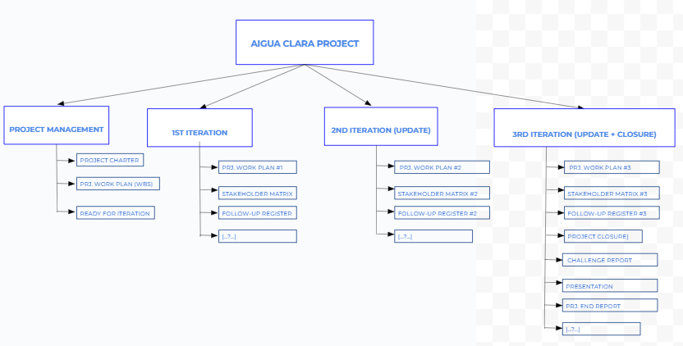

- Roles & responsibilities (optional)
<If the team has decided to change the RASCI from the Project Handbook describe them. The team can decide to add a project manager role. Changes can only apply to the PM, REP and the PCT.>

- Communications Management
<Describe how the project communications will be managed within the project core team. If meetings will be set, communications channels . . .>

- Configuration Management
<Describe how configuration will be managed within the project core team.>

